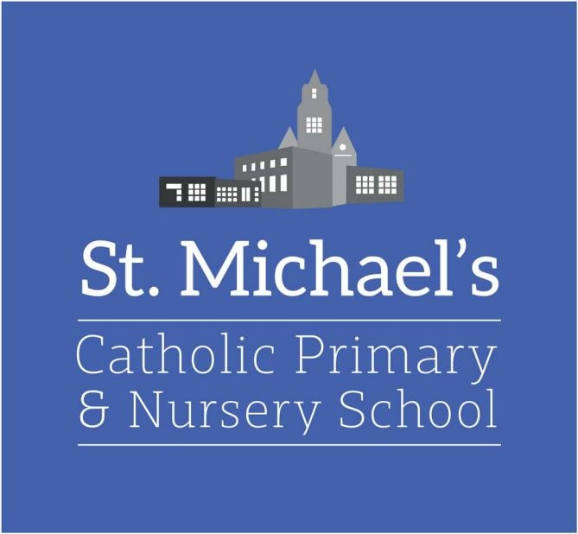

Welcome to St Michael’s Catholic Primary and Nursery School

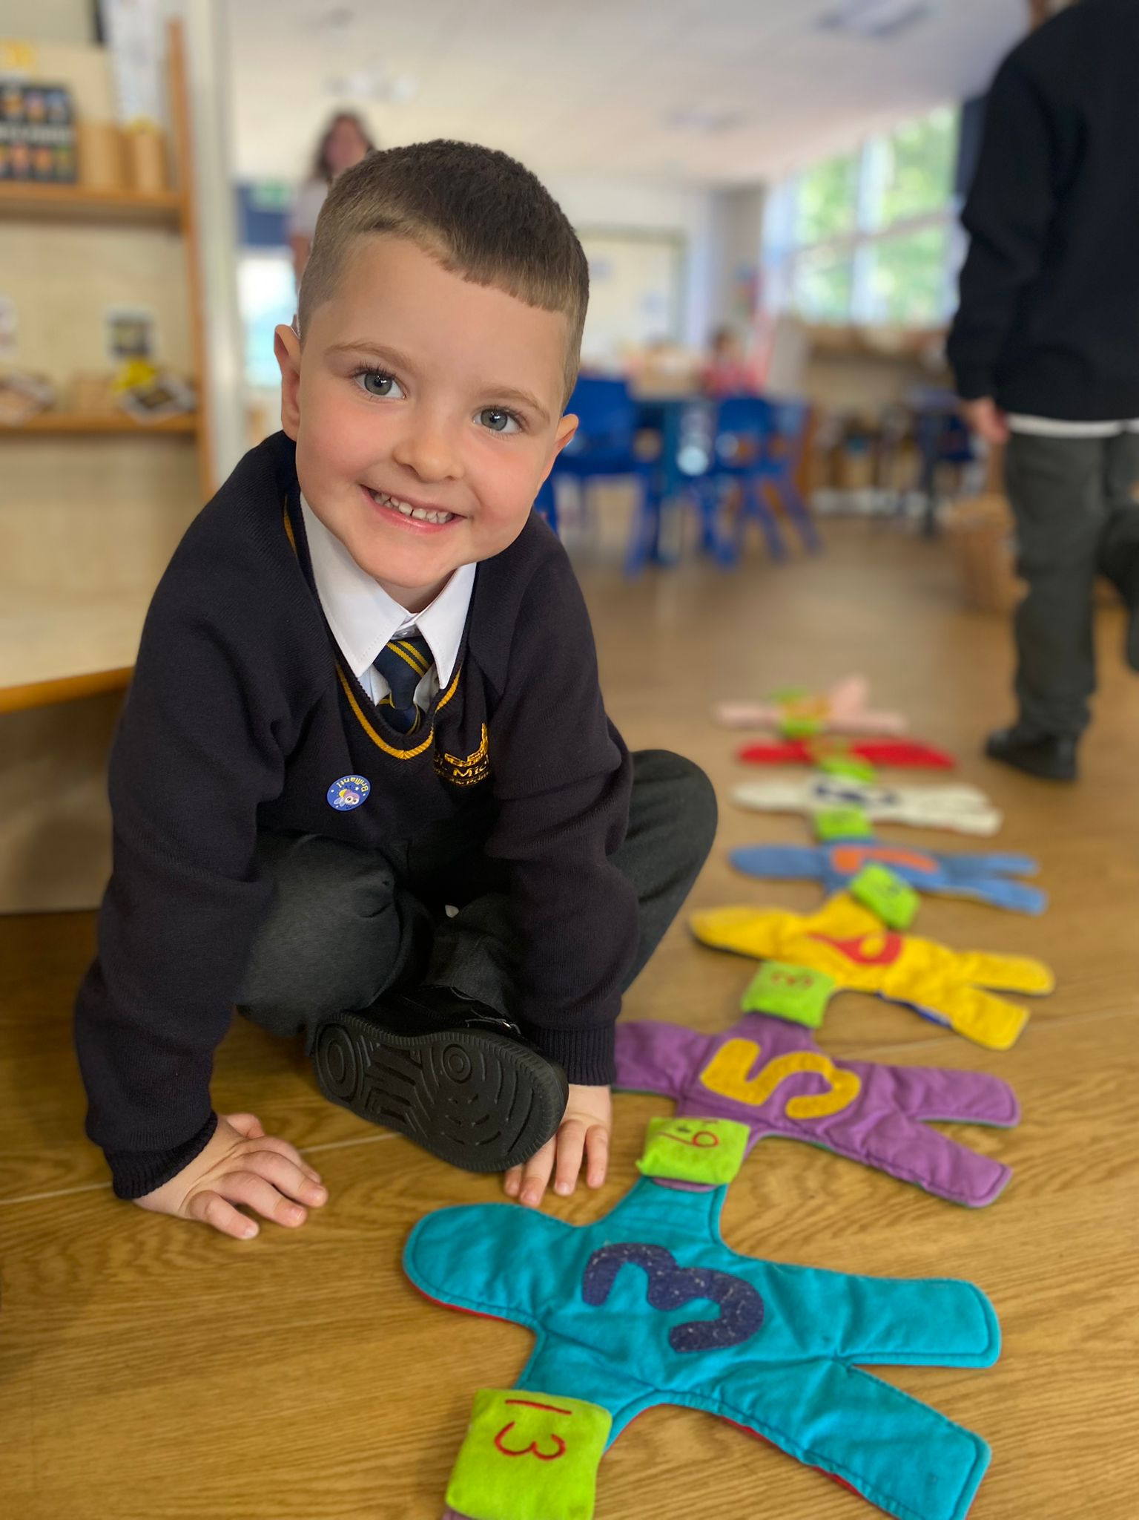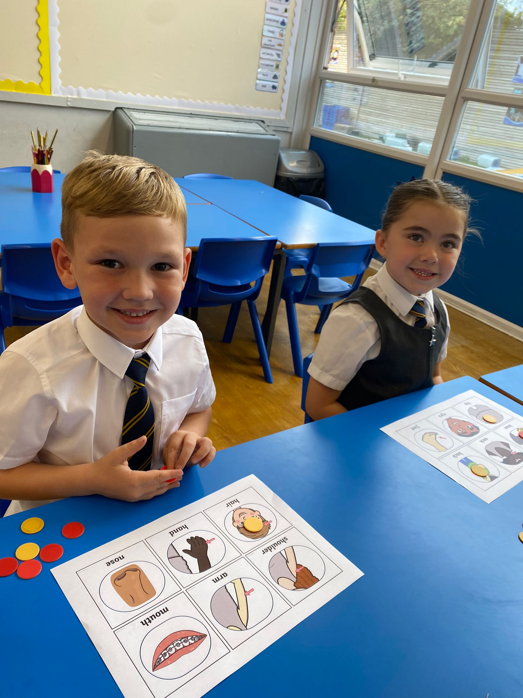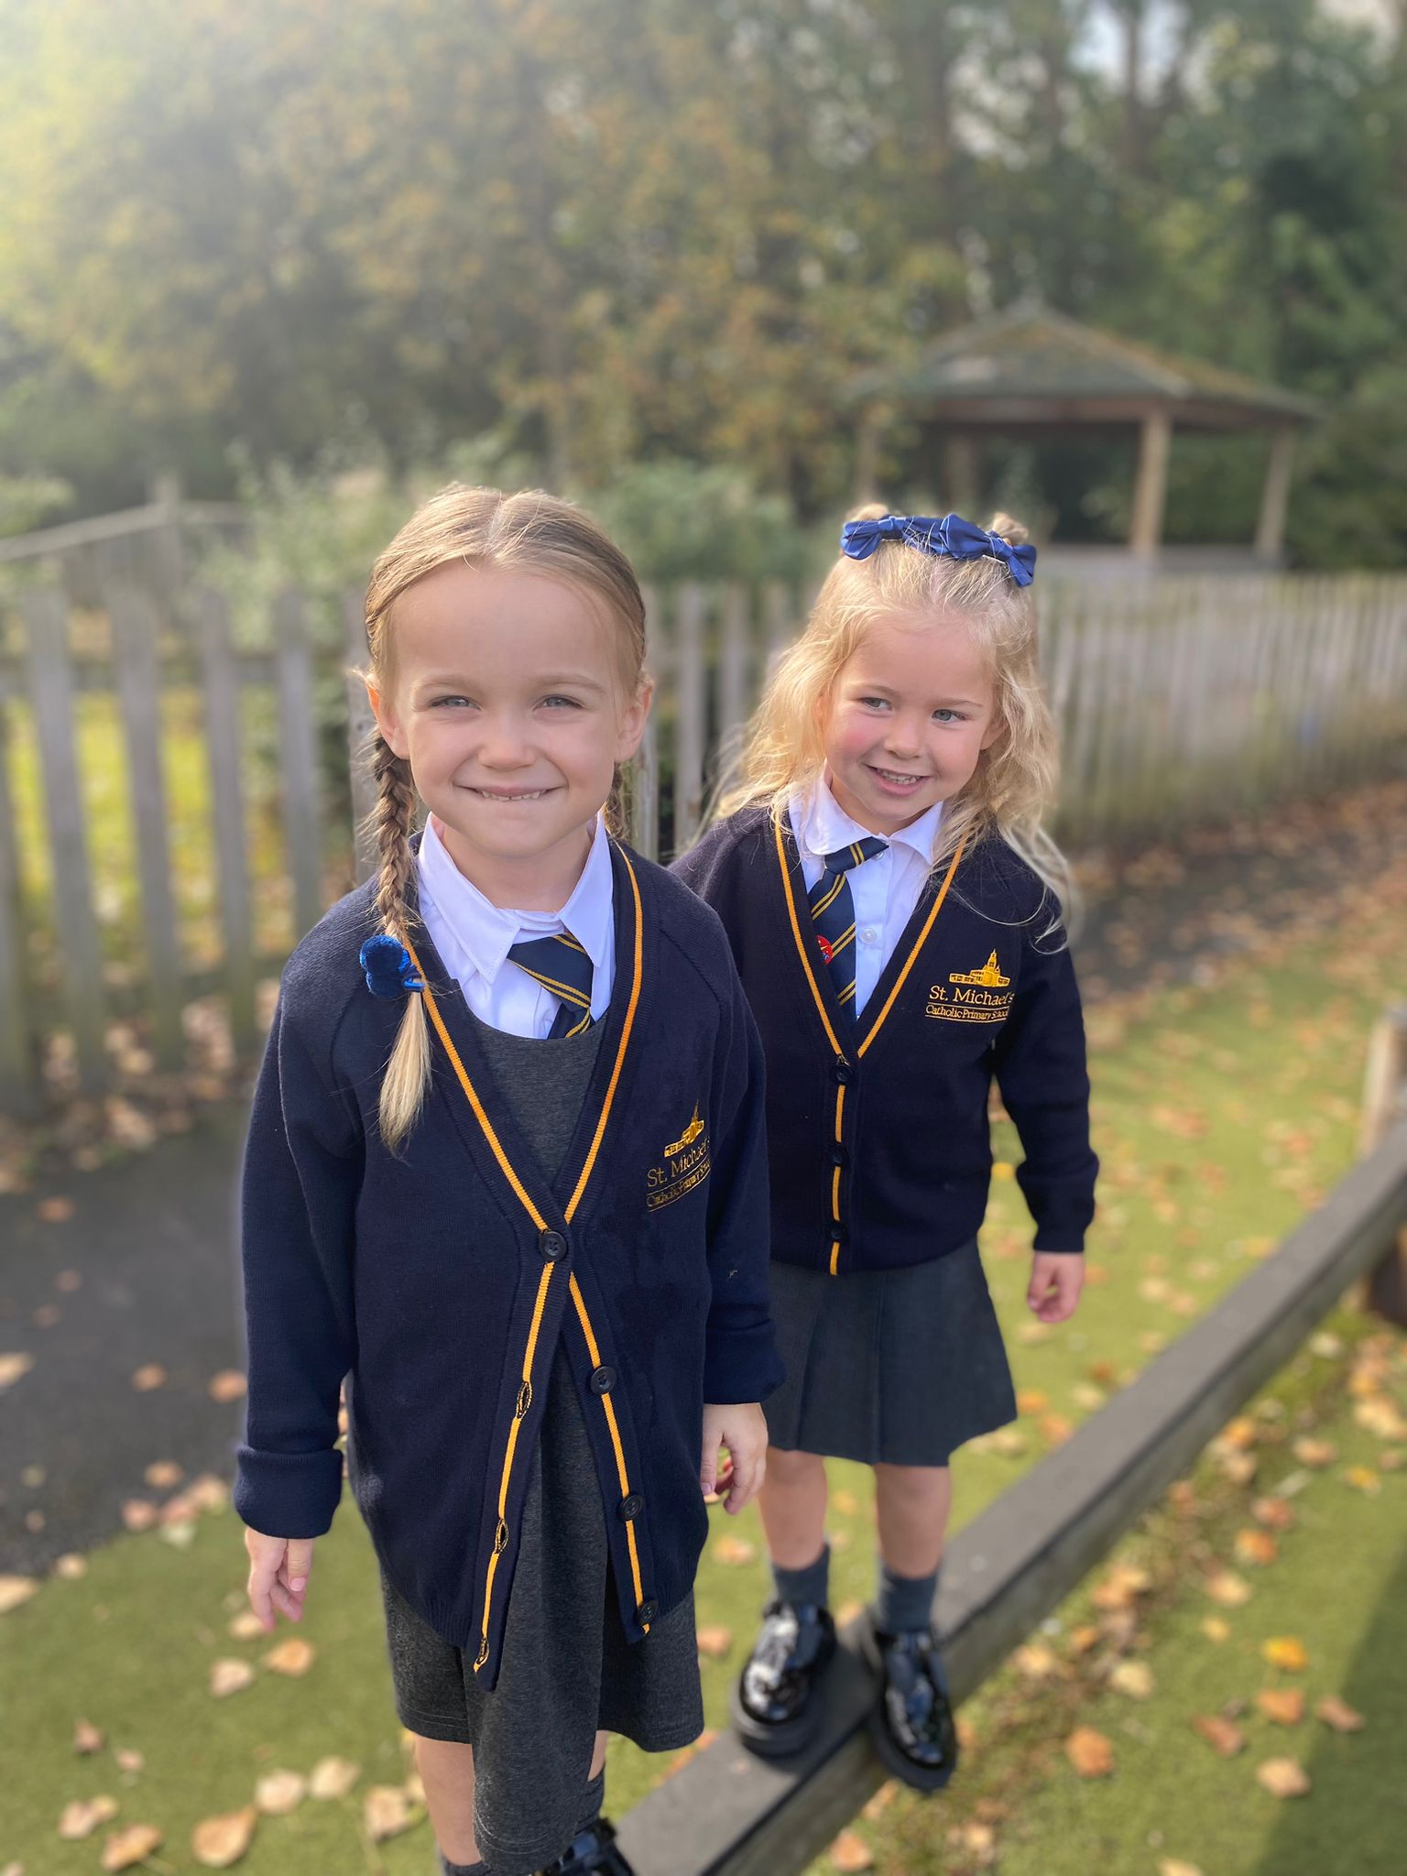

‘Pupils love coming to this school, which leaders aptly describe as an oasis. Leaders have given careful thought to the school environment, from the calming corridors and unique library to the outdoor spaces. Pupils are very well looked after, and they thrive in this caring environment’
Ofted

“In God’s Love We Believe and Achieve”

Welcome to St Michael's Catholic Primary School!
I am the proud Headteacher of a happy and vibrant school where children all learn and grow within a safe environment. We have an excellent team of staff who are all totally committed and dedicated to ensuring each child in our care receives the very best possible education.

The children’s well-being is at the heart of every decision we make. As a Catholic school, our staff value the uniqueness of every member of our school community and are driven in ensuring that they are encouraged and helped to reach their full potential. High expectations of behaviour and positive attitudes to learning are an integral part of our school.

The school provides an exciting and enjoyable curriculum with a wide variety of additional opportunities for children to participate in. These include a wide range of sports, music, art extracurricular activities and academic subjects. We also offer residential visits to all our Key Stage 2 children and provide many opportunities to further our pupil’s educational experiences.

We firmly believe in working in partnership with parents/carers, the parish and the wider community to ensure all our children achieve their very best. As Headteacher I am committed to ensuring St Michael’s continues to grow and flourish in all it does and prepares every member of our school for the next step in their learning journey.

You are very welcome to visit us at any time and if you need any further information, please do not hesitate to contact myself or the school office.

Mr P Loughran
Headteacher
In God’s love we believe and achieve
As a welcoming Catholic community, we will:

- Follow in the footsteps of Jesus | 
- Deliver the best possible education for all our children | 
- Value and love each other in our school and our community | 
- Provide an inclusive environment where everybody reaches their full potential | 
Mission Statement

School Hours

School Day
Nursery  Reception | 8:40am – 3:05pm  8.40am – 3.05pm
Key Stage 1  Years 1 and 2 | 8.40am - 3.05pm
Children can bedropped off between 8.40am -8.50am
Key Stage 2  Years 3 and 4  Years 5 and 6 | 8.40am - 3.10pm  8.40am - 3.15pm
Children can be dropped off between 8.40am -8.50am

Punctuality and Attendance
- Children can enter school between 8:40 and 8:50am and are dropped at the KS2 gate or morning door.
- Staff are on duty in the playground every morning. Reception class children are dropped off at the classroom door by their parents/carers.
- Children arriving in school between 8.50am and 9.00am should proceed straight to the office where they should be signed in by a parent.
- Children arriving after 9.00am should be signed in at the school office by a parent/carer.
- Punctuality and regular attendance are important to your child's progress in school. When absence is unavoidable, please ring the school office before 9:30am to explain your child’s absence. Unexplained absences are now noted in the register as unauthorised and statistics of such must be returned to the local authority.
- Parents of children will be asked to provide medical evidence for all absence.

Absences
If your child is not well you should consult a doctor, keep him or her at home and inform the school of the reason for absence. If your child is absent, medical evidence needs to be provided to the School Attendance Officer where possible.

Holidays
Parents are informed of school holiday dates regularly on newsletters and are published on the school website www.stmichaelscatholicprimaryschool.co.uk
Holidays will not be authorised during term time except in exceptional circumstances.
The Governors have made the decision to have a longer break in May/June to encourage parents to access cheaper holidays. Please refer to guidance issued by Helen regarding absences.

School Meals / Snack / Breakfast
- A free healthy breakfast is currently provided every day from 8.40 – 8.50am as part of the National School Breakfast Program, subject to continued funding.
- A healthy meal is prepared by the school kitchen each day. Lunch costs £3 per day (£15 per week) and should be paid through School Gateway. Please ask the office for more information on the school gateway.
- All children in Key stage 1 are automatically entitled to a Universal free school meal. However, if parents are on certain benefits their child will be eligible to pupil premium which entitles parents to free school meals throughout their school life, should their circumstances remain unchanged. We ask that every parent claiming benefits applies for Free school meals /Pupil Premium as it benefits both the child and the school with additional funding. Please speak to the school office for guidance. We encourage every child to have a school lunch with their friends.
- St Michael’s is part of the ‘Healthy Schools’ scheme.
- Key stage 1 children are provided with fruit free of charge every day.

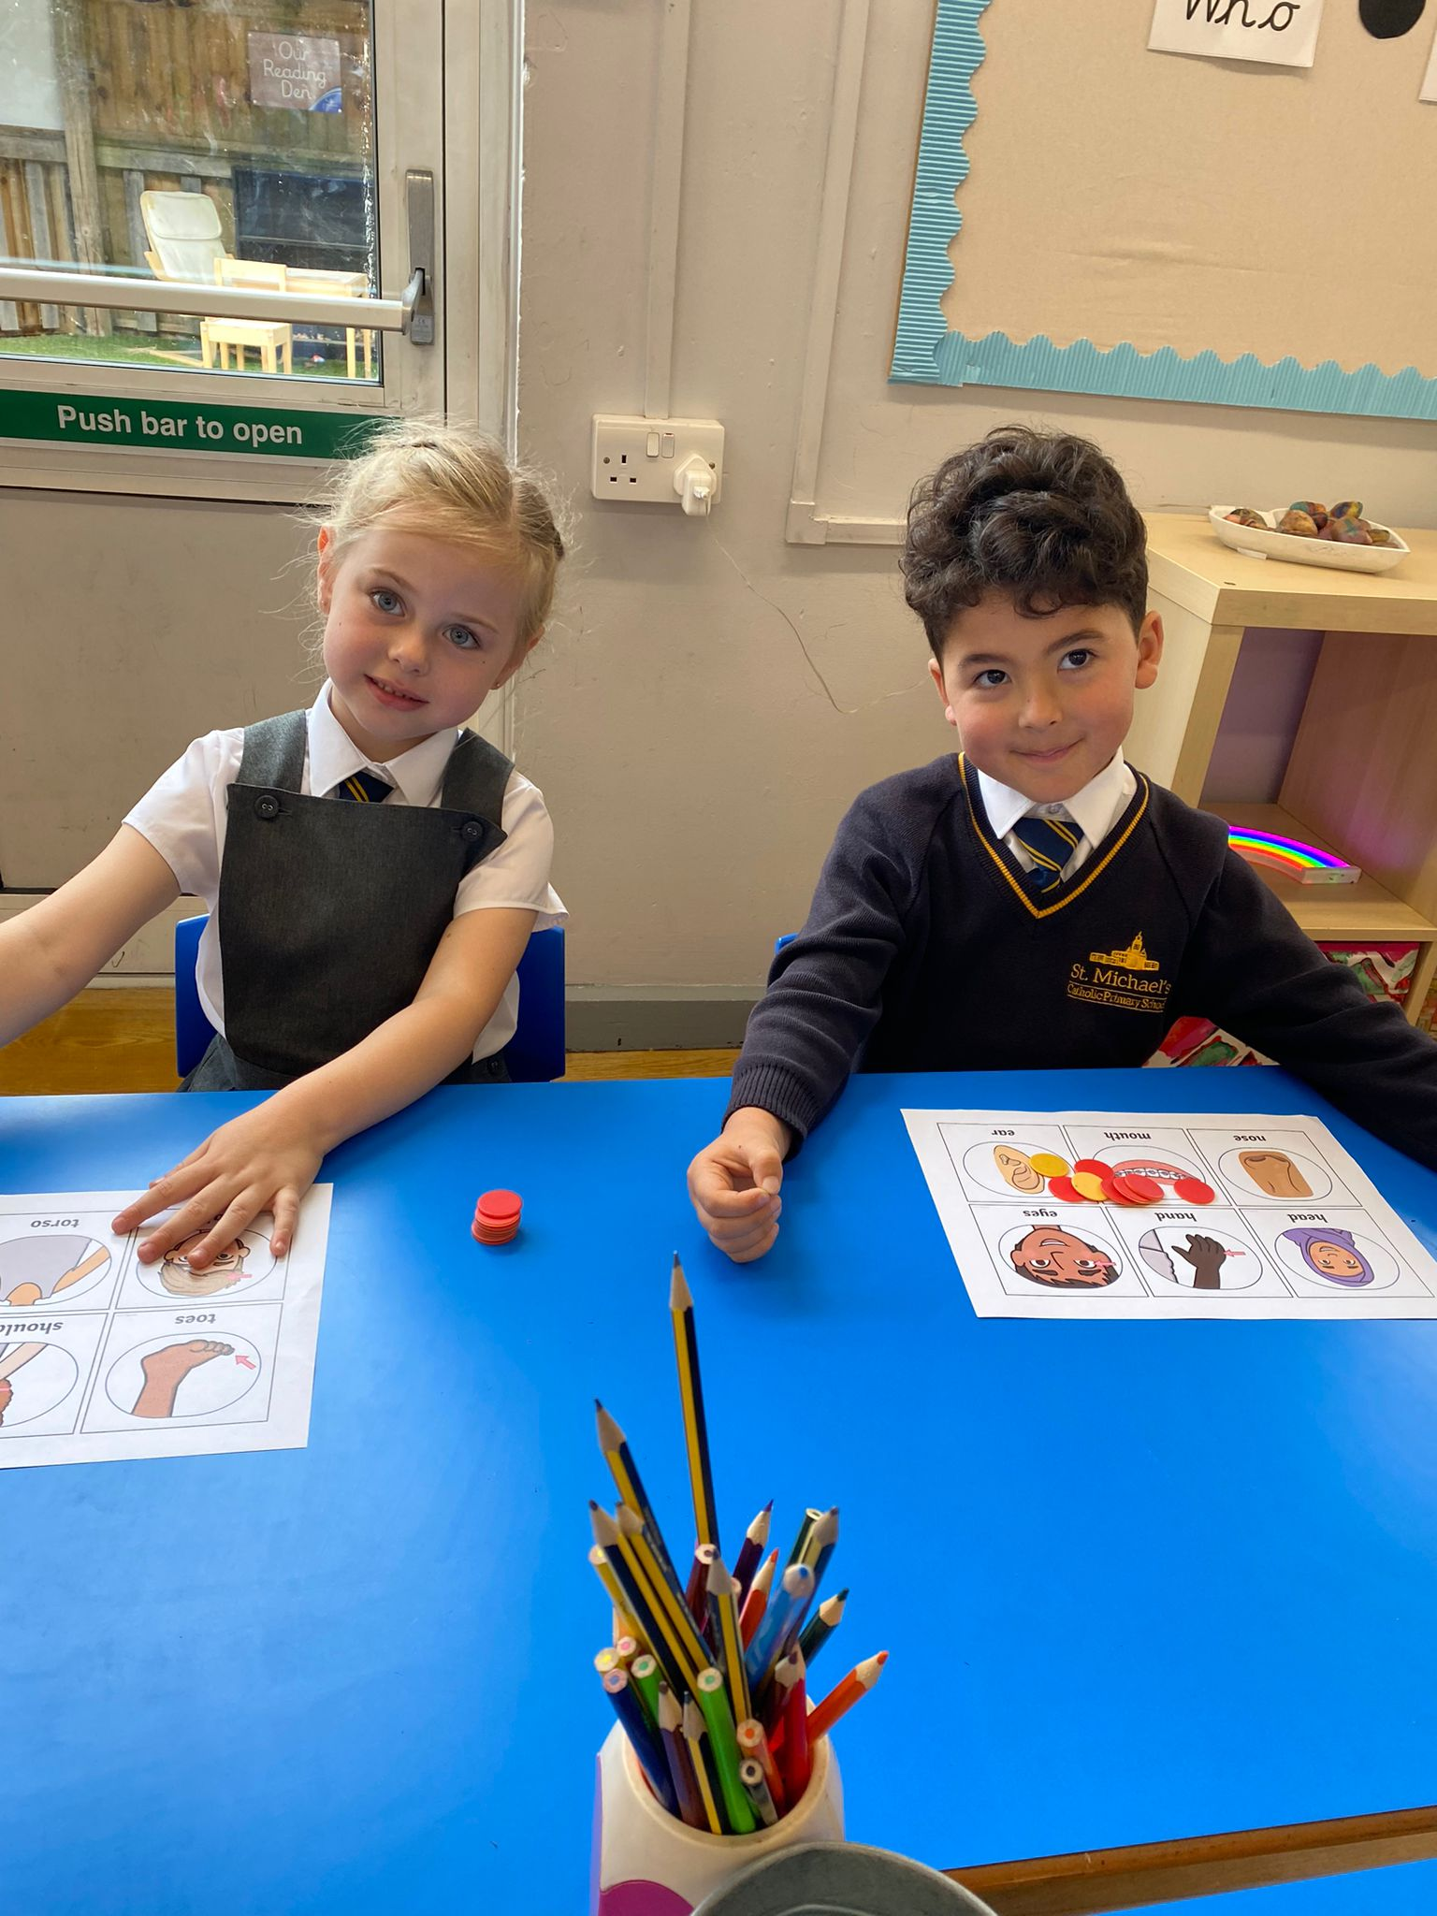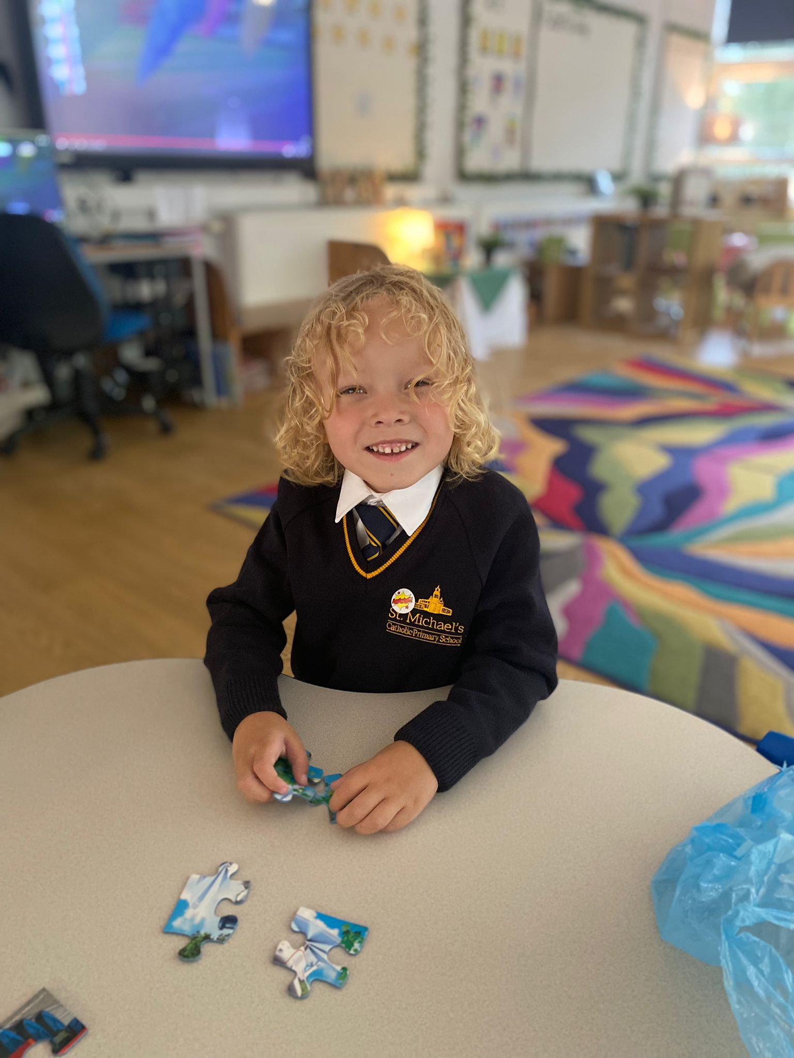

Charging Policy
Parents are asked to pay on a voluntary basis to cover the cost of educational visits/Residentials.

Accidents

It is of vital importance that we have up-to-date phone numbers and details of who we can contact in the event of an emergency. Minor accidents are dealt with in school, but those of a more serious nature require us to contact you. All accidents are recorded within the School Accident Record Book.

Medication

If a child is taking medication which they need during the school day they will need to consult with Helen Leitch (Pastoral team) or the school office to fill in relevant paperwork.
Wherever possible medicine dosage should be arranged so it does not interfere with the school day.
Safeguarding Children and Child Protection
St. Michael’s Catholic Primary School is committed to safeguarding and promoting the welfare of children and young people and expects all staff, volunteers and visitors to share this commitment.
In the event of a safeguarding or child protection concern relating to any pupil, please speak to our safeguarding team who are here to help

Mr Loughran Miss Davies Stef Lockley
Senior Designated Officer Deputy Designated Officers
Alternatively, you can contact Halton Integrated Contact and Referral Team (Children Social Care) on: 0151 9078305 or Emergency Duty Service on: 0345 0500148

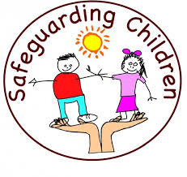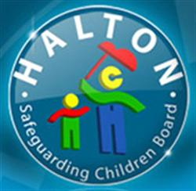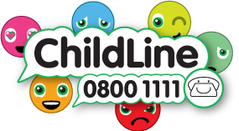

Pastoral Team
St Michael’s Pastoral Team consists of Stef Lockley who is our Pastoral Lead and Helen Leitch who assists with attendance and pastoral care. Both Stef and Helen, work with families and children to overcome barriers to learning. Stef and Helen are available to discuss any issues by phone or in person through the school office and are on the
playground every morning.

School Counsellor
We have a school counsellor Alice Woodward who works at school on a Wednesday.
Parents can arrange a referral to the counsellor by arranging an appointment to
see Stef Lockley or through their child’s class teacher.

School Uniform
Our uniform suppliers are Boydell’s in Victoria Road, Widnes and Kits for All in Lugsdale Road. School uniform is as follows:

Grey trousers, skirt or pinafore, white shirt or blouse, school jumper or cardigan with logo, school tie and black shoes (no trainers or other coloured trims) Grey socks or tights.
PE Kit – Navy T-shirt with logo, navy shorts, pumps / trainers & school hoody for outdoor PE.
Reception Class: All-in-one muddy playsuit required for Forest School curriculum.

Any small ribbons or hair accessories must be school colours.

School Rules
- Follow directions and instructions first time
- Keep hands, feet and objects to yourself
- Call others by their Christian name
- Walk when moving around the school

Secondary Transfer
Children in Year 6 transfer to.

Saints Peter and Paul Catholic High school, Highfield Road, Widnes
Ormiston Chadwick Academy, Liverpool Road, Widnes
Wade Deacon High School, Birchfield Road, Widnes

The Curriculum
At St Michael’s Catholic Primary School, we aim to develop confident, independent learners. The National Curriculum helps us to do this effectively.
Currently the National Curriculum requires that all children between the ages of 5- and 16-years study 4 Core Subjects – English, Mathematics, ICT and Science and in primary schools the following Foundation Subjects – History, Geography, Design and Technology, Art, Music and P.E. Our current Creative Curriculum utilised across the whole school, embeds key skills in a variety of ways.

Collective Worship takes place every day. This also provides a special opportunity for the school community to meet and to consider issues which affect the whole school, covering topics as diverse as bullying, values, festivals, relationships and famous people. Parents have the right to withdraw their children from all, or part of our assemblies and the Religious Education lessons that take place in classrooms.

RED, which is our Catholic R.E Curriculum, is also taught at St Michael’s and accounts for 10% of the weekly timetable.

For children in Nursery and Reception classes, work is based around the Early Learning Goals of Understanding of the World, Physical Development, Communication and Language, Personal, Social and Emotional Education, Reading, Writing and Maths

We also emphasise the importance of the Arts and P.E. in developing children’s abilities and interests. During the time that children are with us, we hope that they will be involved in a range of cultural experiences; through visits to art galleries, visiting theatre companies and working with artists, writers, storytellers and performance artists.

In P.E. we aim to:
- Promote physical activity and healthy lifestyles
- Develop positive attitudes – working as part of a team to encourage fair play and sportsmanship.
- Ensure safe practice and enjoyment

Relationship and Sex Education (RSE) is taught as part of Health Education. We aim to provide children with a working knowledge of their bodies and the ability to make informed choices and decisions about their lifestyles both now and in the future. Children’s questions are dealt with sensitively and honestly when they arise in the classroom. The school uses videos as starting points for discussion in Year 6. Parents are given the opportunity to see these materials each year before they are used with their children.

Please see the Head Teacher if you have any questions or concerns about this aspect of our work in school.

Assessment
Records of pupil progress and attainment are regularly updated. Evidence of pupil’s work is collected and ongoing assessments, both formal and informal, of individual pupil progress are undertaken.

Annual Reports are sent out to parents towards the end ofthe school year along with the results of end of Key Stage national tests (SATS). Open afternoons/evenings are held in Autumn and Spring terms whereby parents may take the opportunity to visit the school, see the children’s work and talk to the class teacher

Homework
All children from Reception to Year 6 classes are asked to read daily at home and parents are asked to sign their child’s reading diary to confirm their child has read. Spellings and Multiplication tables are sent home on a weekly basis, and children are tested on these. The requirement to undertake homework increases as children move up the school. We would appreciate parents’ support in ensuring that the homework set is completed as this supports the work that is being done in school. Copies of the Homework Policy are available from the school office.

Special Educational Needs
If children are identified as having special needs, we support them by drawing on the expertise of our staff within school and through outside agencies. Parents are consulted at every stage of their child’s individual action plan and informed of meetings with educational psychologists / learning support staff. The school has a Special Needs policy which is available to parents. The school’s Local Offer for SEND is available on the school website.

Partnership
We have an open-door policy and work in partnership with Parents. Please contact the school office with any concerns or issues or suggestions.

Extended School

St Michael’s offers the parents the opportunity to access both a Breakfast and After School Club. Both clubs take place on the school premises and are managed independently from the school but under the school umbrella. Breakfast club commences at 7:30am until 8:50am, when children are escorted to their classes and is charged at £4.00 per session, including breakfast. After school club runs from 3.20pm – 5:30pm (5:00pm on a Friday) and is charged at £4.00 per hour including a healthy snack. Parents must complete registration forms before children are able to access this facility. Places are booked directly on iPad. Telephone number will be provided on registration.
Payments must be made on booking by bank transfer

Extra-Curricular Activities
We try to encourage pupils to take an active role in our extra-curricular activities. These clubs are targeted at specific year groups. This year we have provided clubs in the following areas:
Writers Club | Science
Table Tennis | ICT
Art | Athletics
Football | Choir
Rugby | Multi Sports
Homework | Coding Club
Craft Club | Dance
We also provide music tuition to specific year groups during the school day.

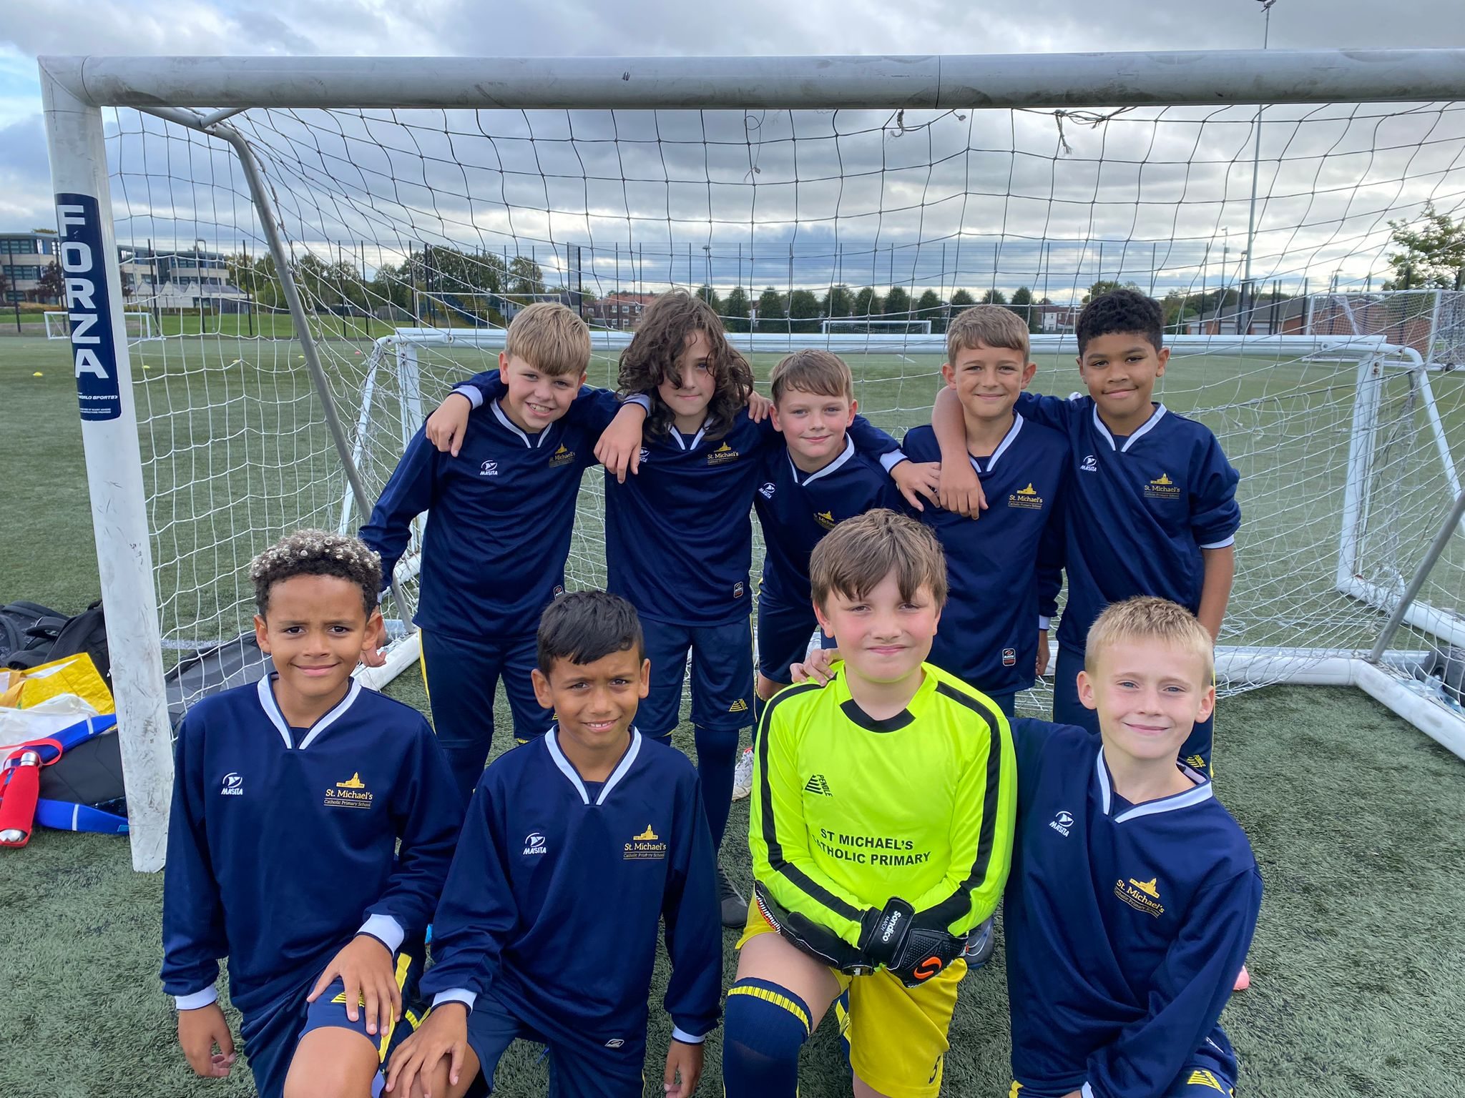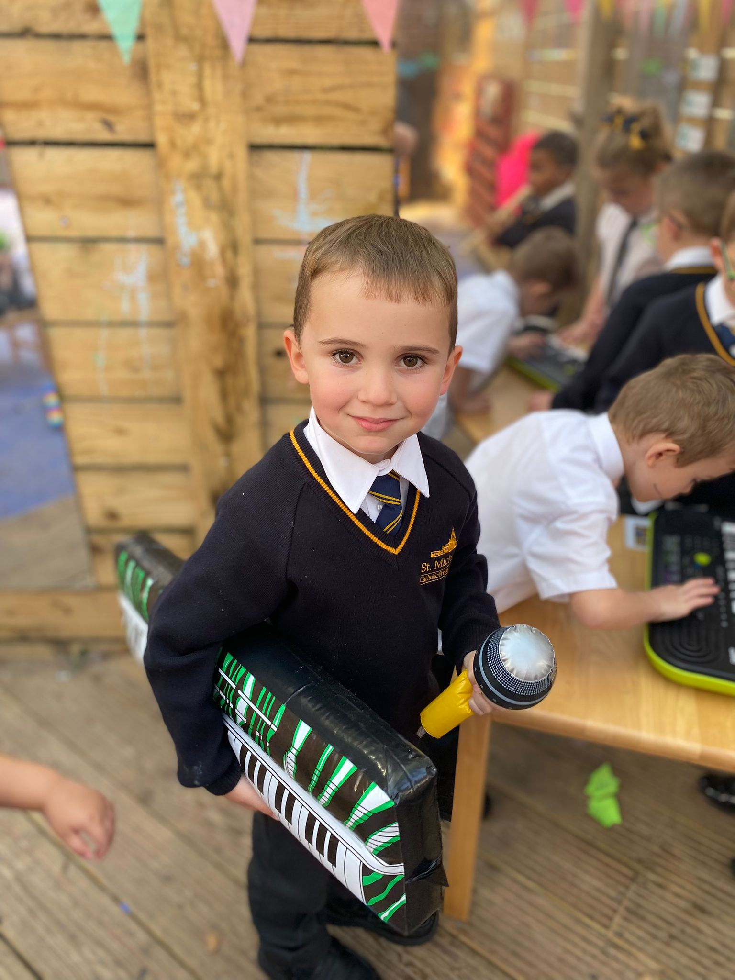

Staffing 2025/2026
Headteacher
Mr Paul Loughran
Designated Child Protection and Safeguarding Officer
School address
St Michael’s Catholic Primary School
St Michaels Road
Widnes
Cheshire
WA8 8TD
Website/Twitter (X)
Telephone number: 0151 424 4468
School website: www.stmichaelscatholicprimaryschool.co.uk
X/ Twitter:@stmichaelscps

Teaching staff

Teacher | Role
Miss J Davies | Assistant Headteacher
Miss Owens | Foundation stage Teacher
Mr Borelan | Year 1 Teacher
Miss Abbott | Year 2 Teacher
Mrs Hillier | Year 2 Teacher
Miss Smith | Year 3 Teacher
Mrs Boardman | Year 4 Teacher
Mrs Leadbetter | Year 5 Teacher
Mrs Pendleton | Year 5 Teacher
Mrs Lawson | Year 6 Teacher
Miss Hawley | Year 6 Teacher
Non Teaching Staff | Role
Miss Strong | Teaching Assistant Foundation Stage
Miss Cooke | Teaching Assistant Foundation Stage
Miss Roberts | Teaching Asssistant Foundation Stage
Miss Magan | Teaching Assistant Foundation Stage
Mrs Jones | Teaching Assistant KS1
Mrs Shelley | Teaching Assistant KS1
Mrs Taylor | Teaching Assistant KS2
Mrs Bent | Teaching Assistant KS2
Mrs Wiggins | Teaching Assistant KS2
Miss Hanrahan | Teaching Assistant KS2
Miss Hambleton | Classroom Support /KS2
Mrs Lyons | Classroom Support /KS2
Stef Lockley | Pastoral Lead
Helen Leitch | Attendance and Pastoral
Mrs Charlesworth | Business Manager
Mrs Spencer | School Administrator
Mrs Rooney | Part Time School Administrator
Miss Glynn | School Administrator
Governing Body (2024-2025)
Headteacher |  | Mr P Loughran
Foundation Parent Governor |  | Mr M Volynchook (Chair)
Foundation Governor |  | Mrs M Morris
Foundation Governor |  | Mr D Fallon (Vice chair)
Foundation Governor |  | Mr J Geraghty
Foundation Governor |  | Cllr Marie Wright
Parent Governor |  | Mrs N Gardner
School Representative |  | Mrs W Pendleton
Foundation Governor |  | Mrs K Edwardson
Foundation Governor |  | Miss M McNicholas
LA Governor |  | Mr E Dourley
Midday Assistants
Mrs Lynch |  | Mrs Wise
Miss McCormack |  | Mrs Carroll
Mrs Macklin |  | Miss Glynn
Miss Carmon |  | Mrs Noscoe
Miss Power

Extended School Staff
Mrs Lyons | Mrs Hanrahan
Mrs Chadwick | Miss Cooke

