St Michael’s Catholic Primary School Questionnaire Results 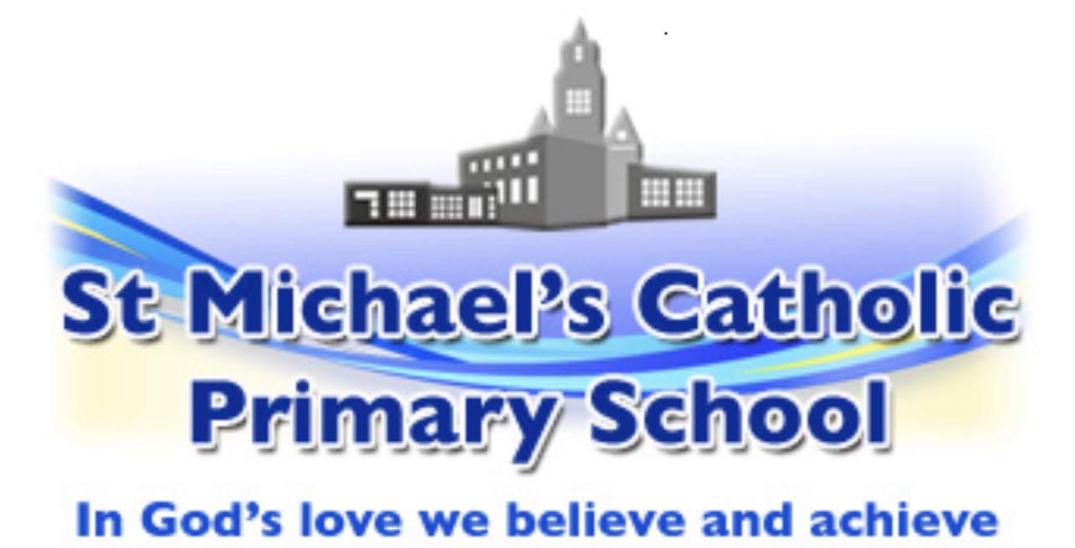

Whole School (157 Responses) – October 2022

Please only tick one box per statement: |  | Strongly Agree/ Agree | Disagree/  Strongly Disagree | Don’t know
1 | My child is happy at this school | 98% | 1.5% | 0.5%
2 | My child feels safe at this school | 99.5% |  | 0.5%
3 | The school has high expectations for my child | 99% |  | 1%
4 | The pupils are well behaved | 97% | 1% | 2%
5 | My child does well at school | 99% | 0.5% | 0.5%
6 | When I have raised concerns with the school they have been dealt with properly | 91% | 2% | No Concerns  7%
7 | The school communicates well with families (ie email / text / twitter /direct teacher contact) | 99% | 1%
8 | The school provides a good level of pastoral care | 97% |  | 3%
9 | The school provides a broad and balanced curriculum with a good range of subjects and activities for my child | 99% |  | 1%
10 | The school provides a range of after school clubs/activities. | 94.5% | 0.5% | 5%

