St Michael’s Catholic Primary School
Reading
A Parent Guide
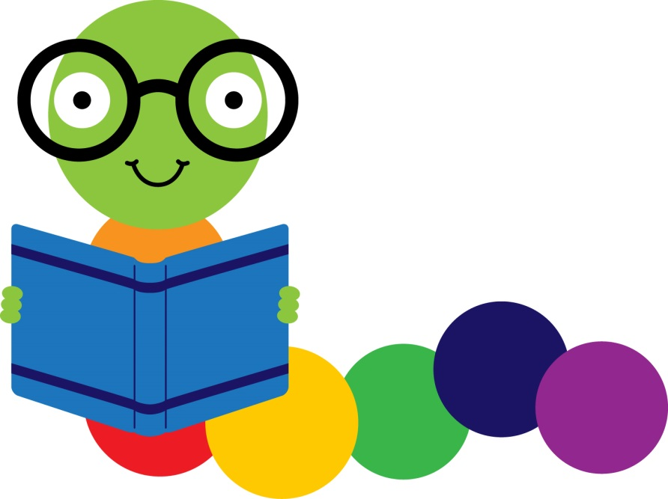
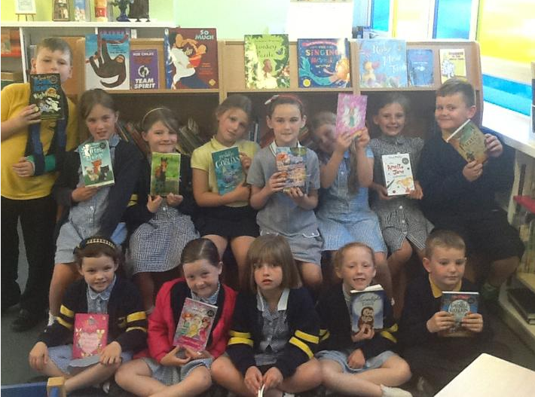

3
USE THE WEBSITE
You will find lots of helpful information on the school website.

2
DO IT OFTEN
Make it a habit in your house - reading time together - the more you do it the better they will be.

1
MAKE IT FUN
Children will want to read if they have good books which make it feel special and fun.
TIP
TIP
TIP
Plan to visit the library at least twice a month after school.
Download the kindle app on an iPad or on your phone and look for free books and magazines you can read.
Let your child see you reading as much as possible, books or magazines. This will encourage them to read also.

What can I do at home?
Try and choose a quiet time every night with your child somewhere really comfortable. Snuggled up on the couch with the TV off or lying on the bed before bedtime are good places to share a story. Let your child hold the book. If it is a picture book use the pictures first to ‘read’ the story together. With older children ask them to tell you what has happened previously in the story before you start reading. Take it in turns to read - maybe a line or a page each and when you read try and add expression to your voice - give the characters funny voices for example. Encourage your child to do the same.
Children learn good reading habits by adults sharing reading time with them.

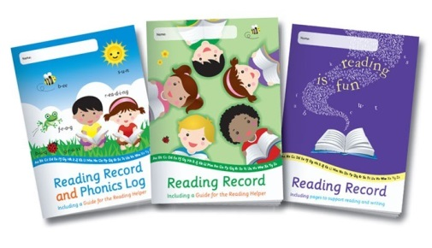
READING RECORDS

Sometimes parents are unsure what to write in reading records. Some things you might tell us are…
Is your child enjoying the story/book?
Can they remember the story so far?
Are they only reading the pictures?
Do they understand the words in their book?
Are they having a good go at new words?
Which ones did they find easy / which ones did they struggle with?
What different ways are they using to try and work out a new word?
Is your child aware of punctuation?
Are they reading with expression?

Don’t worry if your child doesn’t read words perfectly - if they read ‘house’ instead of ‘home’ or ‘Good dog Spot’ instead of ‘Good boy Spot’ that is ok. These things don’t change the meaning of the story or book and shows that they are reading with some understanding. Only stop them if they are reading something completely different to the words in the book – sometimes you can do this by repeating what they have just said and ask them does it sound right? Usually they will say no and then you can have a go at reading together what the words actually say.
Every time you read with your child, whether it is their school reading book or something else try to record it in their reading diary. This helps us see how much practise your child is getting and the range of things they are reading.

you can do this by repeating what they have just said and ask them does it sound right? usually they will say no and then you can have a go at reading together what the words actually say.

Every time you read with your child, whether it is their school reading book or something else try to record it in their reading diary. This helps us see how much practise your child is getting and the range of things they are reading. It would be a good idea to have your child do some of this recording as well.
Establish Good Habits
Make reading a priority in your house and your children will be better readers. Better readers will do better in all areas of the curriculum, it really is that simple.
Print is all around us. Encourage your child to read EVERYTHING they can see! Read labels in the supermarket; read street signs, cereal packets; a page in a magazine - wherever you can take the opportunity for them to practise their reading skills. If you buy them a new Xbox game or download a new app ask them to read the instructions to you. It doesn’t matter what they read just as long as they read!

